**FESTIVAL EVENT REGISTRATION**

**SYSTEM**

**Project Title Festival Event Registration System**

**Objective** Making a web application which

helps in organizing and managing

events more efficiently and

smoothly.

**Undertaken by** Vemula Prathyusha (845121)

Kavitha Dhenuvakonda (844893)

Navya Biju Jose (844996)

Sruthi S (845209)

Ramya Kota (844947)

**Supervised by** Naveen Kumar

**TABLE OF CONTENTS**

**SL NO CONTENTS PAGE NO**

1Abstract 4

2 Introduction 5

3 System Analysis 7

4 System Design 8

4.1 Project Modules

4.2 Use Case Diagrams

4.3 Hardware And Software Requirements

5 Software Tools Used 12

6 Conclusion 13

**ABSTRACT**

Our main aim of this project is to make and provide an ideal software solution to register events, to unregister events, update user info, to protect user data and to save the valuable time of the user.

**INTRODUCTION**

Event management is one of the most rapidly growing majors in the country.

**Objective of the Project:**

This project performs the task of developing a web application that enables the users to register the data very easily. The main purpose of festival event registration system is to provide a platform for the users to register and view the information about the events which are about to take place in the upcoming festival. They can first register into the website and see through the information such as details about the events like the venue, theme of the event, participants, etc. The user can then login to see his/her profile. The registered candidate’s information are recorded and stored in database. The user can login and update the information, delete any unwanted data, arrange the information accordingly so that the user can go through a user friendly and know all the whereabouts of their events in the festival.

**Scope of the Project:**

The scope of the project is just limited to a laptop or a pc with an internet connection. Firstly the user, need to register to the website. After the registration process is completed each one of them gets a password and login ids. With these two they can access their account and for any query they can contact the administrator by sending a mail.

**Problem Definition:**

In the existing system lot of paper work was required and it was time consuming process. As it was manual process retrieving data was very difficult. More than one person cannot access the data.

**Festival Event Registration System (FERS)** is a web based application that supports online. Development of FERS is an attempt to address the problems of managing registration forms. The main goal of this software is to give working solution to store, manage and consolidate the registration data.

**System Analysis**

This is an online event registration system software project. The system allows only registered users to login and new users are allowed to resister on the website. This is a web application developed in Java, Jsp and SQL server. The user has to provide his/her necessary data on registration site. Then the user can login using his/her credentials and view the event catalog and browse various event programs on the website. The user can participate in multiple events. Each event can be participated only once by a user. The user can update his user information at anytime. The project provides most of the basic functionality required for an event. It allows the user to select from a list of festive event types. Once the user enters an event type, the system then allows the user to view the information such as date and time of event and all other necessary information regarding the event. The admin will register the events for the users to participate in the event registration using admin account. All this data is logged in the database and the user is given a receipt number for his booking.

**System Design**

**3.1 Project Modules**

**Registration:** Participants can register online for taking part in events of the festival.

**Login:** Participants who have already registered can login.

**Event Registration:** Participants can register into events from event catalog.

**Event Deregistration:** Participants can unregister from events in the event catalog.

**Update:** Participants can update their information.

**3.2 Use Case Diagrams**

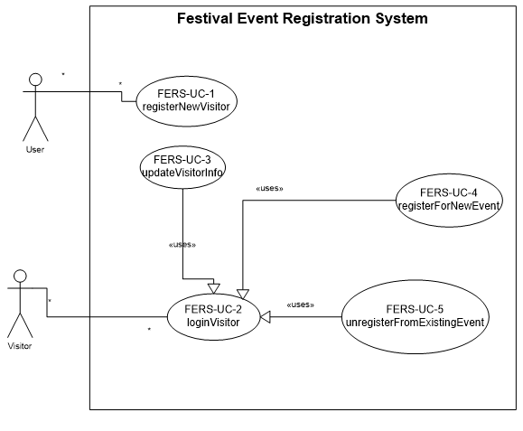

Register Visitor

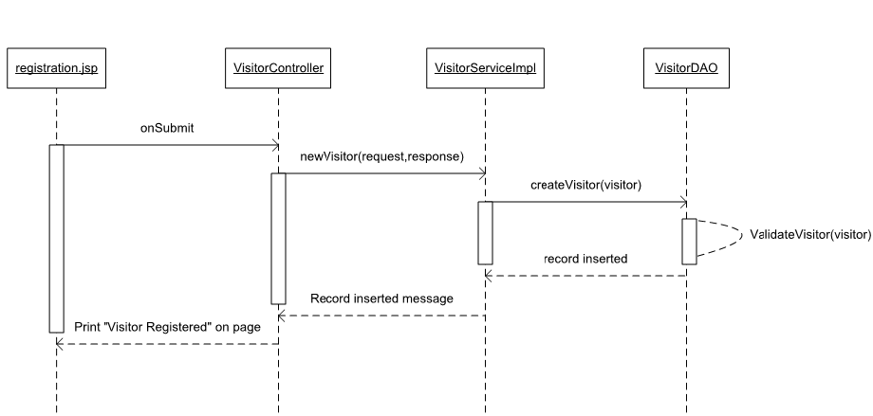

Login Visitor

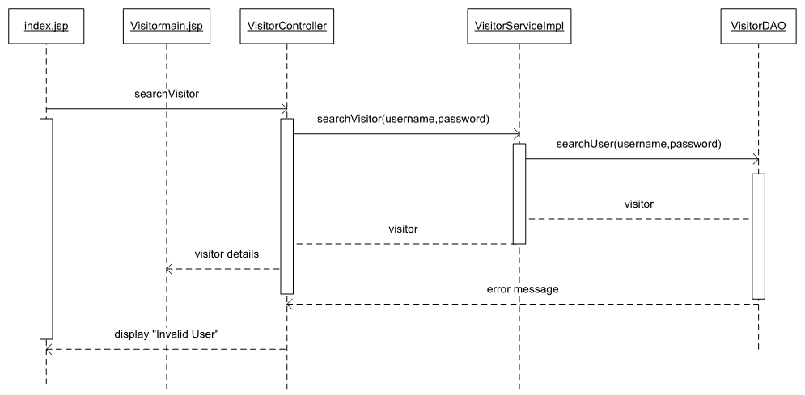

Update Visitor

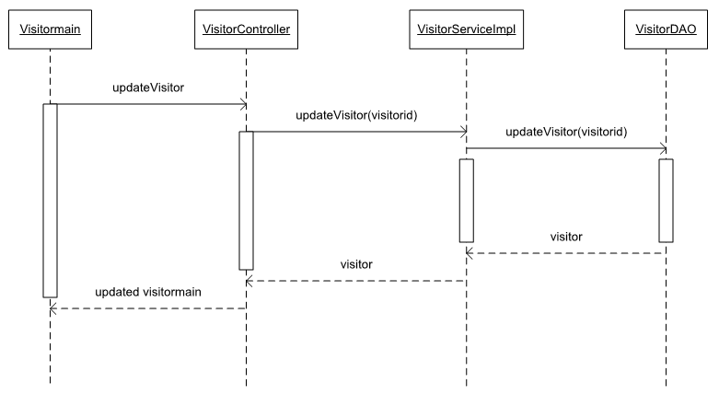

Register Event Visitor

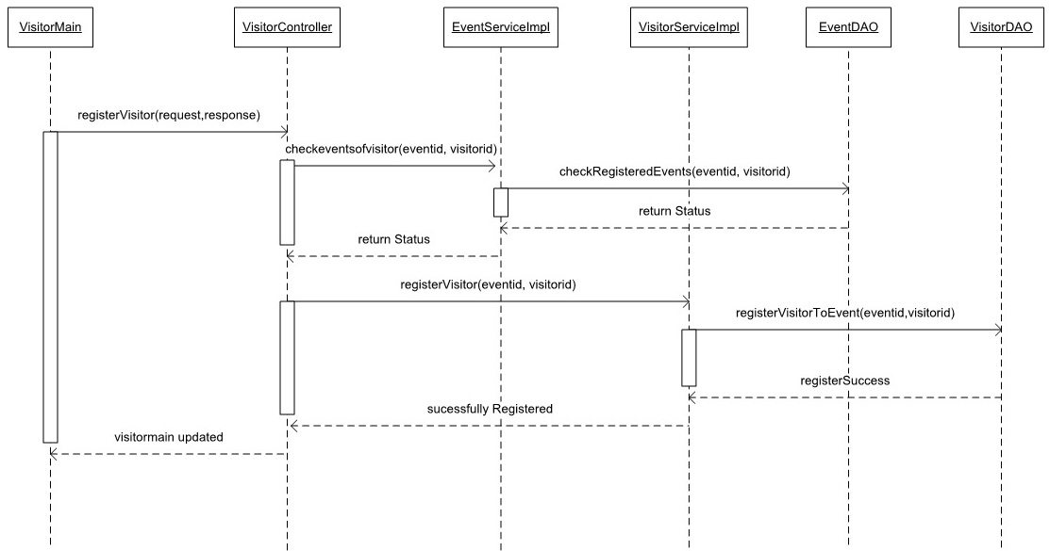

Unregister Event Visitor

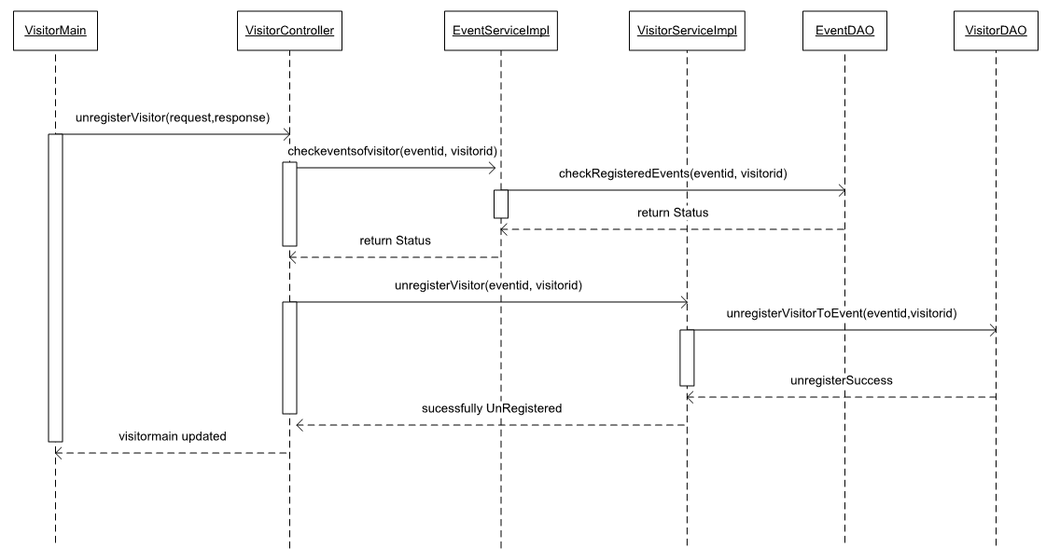

**3.3 Hardware And Software Requirements**

* Programming language: Java
* Front-End: Html5, CSS3, JavaScript, JSP, Junit
* Databases: MySQL Server
* OS: Windows XP
* Browser: Internet Explorer, Chrome
* Web Server: Apache Tomcat 8
* Tools: Eclipse, STS
* Framework: Hibernate with spring MVC

**Software Tools Used**

**HTML:** Page layout has been designed in html.

**CSS:** CSS has been used for all designing part.

**JavaScript:**  The validation task has been developed by JavaScript.

**JSP**: All the front end logic has been written in JSP.

**Java:** All the business logic has been written in Java.

**MySQL:** MySQL database has been used as database for the project.

**Tomcat:** Project will run over the Tomcat server

**Conclusion**

This project was successfully completed, within the time span allotted. All the modules are tested separately and input together to form the main system. Finally the system is tested with real data and everything worked successfully. Here, management of registration form and evaluation is done very efficiently as a result of which the project has a good scope.